Matlab solvers

fmincon
Most used algorithm for QP are:
- active set
- interior-point
- gradient projection
- alternating direction method of multipliers

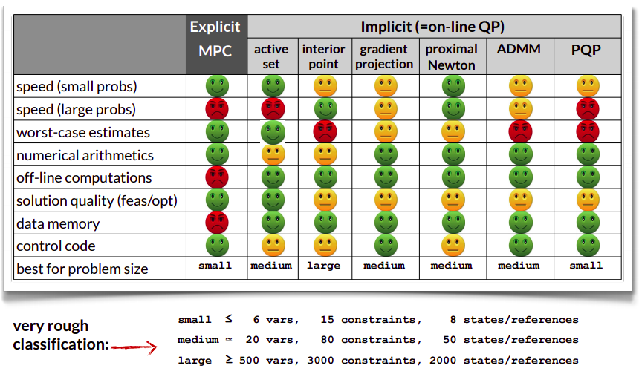

Robust MPC

Tube-Based RMPC

In presence of bounded uncertainties, all the possible trajectories combinations of an uncertainty system lie in a bounded space of a nominal trajectory, called tube.
Tubes allows to satisfy of the constraints for all the disturbance sequence ensuring that the nominal trajectory satisfies suitably tightened constraints.

Dynamic system

Considering the uncertain linear system:
$$x^{+}=Ax+Bu+w$$
where: $x\left(x_{0}, u, w\right)$ solution of the uncertain system
$w∈W$, $w$ state disturbance, $W$ state disturbance constraint set

Considering a nominal linear system:
$${\overline{x}}^{+}=A\overline{x}+B\overline{u}$$
where: is $\overline{x}\left({\overline{x}}_{0}, \overline{u}\right)$ solution of the nominal system

Preamble

Open-loop tube
Considering an uncertainty linear system and a nominal one, the deviation of the actual state from the nominal state is:
$$e=x-\overline{x}$$
The error evolution derived, for $x_{0}={\overline{x}}_{0}$, is:
$$e^{+}=Ae+w ⟶e_{i}=\sum_{j=0}^{i-1}{A^{j}w\left(j\right)}$$

The uncertainty set is defined accordingly:
$$e_{i}∈S\left(i\right)=\sum_{j=0}^{i-1}{A^{j}W}$$
Finally, the tube is defined as:
$$X\left(x_{0},u\right)={\left[\begin{matrix}X_{0}\left(x_{0}\right) & ⋯ & X_{N}\left(x_{0},u\right)\end{matrix}\right]}^{T}$$
where: $X_{i}\left(x_{0}, u\right)=\left\{{\overline{x}}_{i}\right\}⊕S_{i}$
$\left\{{\overline{x}}_{i}\right\}$ nominal state defining the centre of the tube

It can be proof that with an open loop control, the tube $X_{i}$ increases in dimension as i increases, since the uncertainty set increases and then the trajectory can diverge.
The solution to this is using a feedback control to control the size of $S_{i}$ and then make the actual trajectory converge to the nominal one.

Closed-loop tube
The feedback control law proposed is:
$$u=\overline{u}+K\left(x-\overline{x}\right)=\overline{u}+Ke$$
The state x satisfies the difference equation:
$$x^{+}=Ax+B\overline{u}+BKe+w$$
The deviation and the error evolution:
$$e=x-\overline{x}$$
The error evolution derived, for $x_{0}={\overline{x}}_{0}$, is:
$$e^{+}=\left(A+BK\right)e+w=A_{K}e+w ⟶e_{i}=\sum_{j=0}^{i-1}{A_{K}^{j}w\left(j\right)}$$

The uncertainty set is defined accordingly:
$$e_{i}∈S_{K}\left(i\right)=\sum_{j=0}^{i-1}{A_{K}^{j}W}$$
The tube generated is:
$$X\left(x_{0},u\right)={\left[\begin{matrix}X_{0}\left(x_{0}\right) & ⋯ & X_{N}\left(x_{0},u\right)\end{matrix}\right]}^{T}$$
where: $X_{i}\left({\overline{x}}_{0}, \overline{u}\right)=\left\{{\overline{x}}_{i}\right\}⊕S_{i}$
$\left\{{\overline{x}}_{i}\right\}$ nominal state defining the centre of the tube

Existence of the minimal robust positive invariant set
The uncertainty set at a certain instant $S_{K}\left(i\right)$ can be replaced by the:
- Minimal robust positive invariant set $S_{K}\left(∞\right)$ to obtain a more conservative outer-bounding tube
- $S_{K}\left(H_{p}\right)$ to obtain a less conservative outer-bounding tube

Origin condition relaxation
Furthermore since $S_{K}\left(∞\right)$ exists whenever $A_{K}$ is stable, can be proven that it is possible to relax the condition $x_{0}={\overline{x}}_{0}$.

Constraints
Defining the uncertain and nominal system constraint set as:
$$\left\{\begin{aligned}x∈X_{c} \\ u∈U_{c}\end{aligned}\right.⟹\left(x,u\right)∈Z$$
$$\left\{\begin{aligned}\overline{x}∈{\overline{X}}_{c}=X_{c}⊖S_{K}\left(∞\right) \\ \overline{u}∈{\overline{U}}_{c}=U_{c}⊖KS_{K}\left(∞\right)\end{aligned}\right.⟹\left(\overline{x}, \overline{u}\right)∈\overline{Z}=Z⊖\left(S_{K}\left(∞\right)×KS_{K}\left(∞\right)\right)$$

The tube-based MPC is made up by:
- Nominal state-control trajectory that satisfies the tightened constraint:
$$\overline{x}\left(k\right), \overline{u}\left(k\right)$$
- Feedback controller that track the nominal trajectory
$$u=\overline{u}+K\left(x-\overline{x}\right)=\overline{u}+Ke$$
where: $e=x-\overline{x}$ deviation of the actual state
The nominal state-control trajectory can be:
- generated once at initial time
- generated sequentially using standard MPC for deterministic system

Nominal trajectory

For the nominal system
$${\overline{x}}^{+}=A\overline{x}+B\overline{u}$$
it is solved the standard optimal control problem:
$$\begin{matrix}{\overline{V}}^{*}=\min_{\overline{x},\overline{u}}{\overline{V}\left(\overline{x},\overline{u}|k\right)} \\ s.t. \left|\begin{aligned}dynamic model \\ constraints\end{aligned}\right.\end{matrix}$$
$$\overline{V}\left(\overline{x},\overline{u}|k\right)=\sum_{i=k}^{k+H_{p}-1}{l\left(\overline{x}\left(i|k\right),\overline{u}\left(i|k\right)\right)}+V_{f}\left(\overline{x}\left(k+H_{p}|k\right)\right)$$
which solution gives the control law:
$${\overline{u}}^{*}=\overline{κ}\left(\overline{x}\right)$$

Then the controlled nominal system is described by:
$${\overline{x}}^{+}=A\overline{x}+B\overline{κ}\left(\overline{x}\right)$$

Feedback controller
The feedback controller generates the (proposed) control law:
$$u=\overline{κ}\left(\overline{x}\right)+K\left(x-\overline{x}\right)$$

Then the controlled system is described by:
$$x^{+}=Ax+B\overline{κ}\left(\overline{x}\right)+K\left(x-\overline{x}\right)+w=Ax+B\overline{κ}\left(\overline{x}\right)+Ke+w$$
where: $e=x-\overline{x}$ deviation of the actual state, satisfies:
$$e^{+}=\left(A+BK\right)e+w=A_{K}e+w$$
which is the error evolution.

System state and dynamic model
Considering two systems:
- system with state $\left(x,\overline{x}\right)$ satisfies:
$$x^{+}=Ax+B\overline{κ}\left(\overline{x}\right)+Ke+w$$
$${\overline{x}}^{+}=A\overline{x}+B\overline{κ}\left(\overline{x}\right)$$
- system with state $\left(e,\overline{x}\right)$ satisfies:
$$e^{+}=A_{K}e+w$$
$${\overline{x}}^{+}=A\overline{x}+B\overline{κ}\left(\overline{x}\right)$$
Since they are proportional with through an invertible matrix T, they are equivalent.

Uncertainty set S
Setting the initial condition: $x\left(0\right)=\overline{x}\left(0\right)→e\left(0\right)=0$

Constraints

Tightened constraint
$$\left(\overline{x}, \overline{u}\right)∈\overline{Z}=Z⊖\left(S_{K}\left(∞\right)×KS_{K}\left(∞\right)\right)$$
Suppose $Z$ is a polytope and described by a set of scalar inequalities:
$$c^{'}z≤d$$
It can be proof that constraints of this form can be replaced by constraint of the form:
$$c^{'}\overline{z}≤d-{\left(1-α\right)}^{-1}θ_{N}$$
ensuring that the satisfaction of this the tightened constraint by the nominal system ensures that the uncertain system satisfies the original constraint.

Time-varying Tightened constraint
The constant tightened constraint set $\overline{Z}$ is conservative, reducing unnecessarily the feasible set ${\overline{X}}_{N}$. This conservativeness can be decreased using time-varying constraint set:
$$\overline{Z}\left(k\right)=Z⊖\left(S_{K}\left(k\right)×KS_{K}\left(k\right)\right)$$

Final Notes
- Computation of tightened constraints may be expensive

